**ENGR 4020 Lab 10 [25 pts]**

**Line Identification with Computer Vision**

**Submit by 4/24/2020**

**Tasks**

Video is an example of consecutive images at discrete time steps. In this lab, you will be writing code to find lines in a set of 15 images, mimicking video processing.

This lab consists of an example for you to complete demonstrating line identification in a series of images.

At the start of your program, use the customary close all, clear all, clc. Then, because we want to process a 15 images sequentially, start a for loop, for the variable k=1:15. Any for loop must also have an end statement, which should be located at the very bottom of your program.

To successfully read in an image, we will use the command imread, which expects a string representing the filename as an input argument. To create this for a series of images, we will concatenate the string with the image number (based on the filenames of available images).

Then we can read and preprocess the image by resizing, converting to black and white, and rotating.

Then, use an edge detector to get the edges. I use Canny, but you can try others, and play with the threshold values.



Then, we will find the peaks and lines using the Hough Transform.

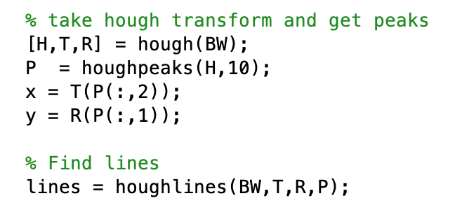

Finally, we will show the image and resulting identified lines.

When you have correctly completed this exercise, submit your .m file and any documentation of completion by the due date. Any left over time in lab is to be used for work towards the final project competition.